SKIBBE – FACTORY OF CONFUSION

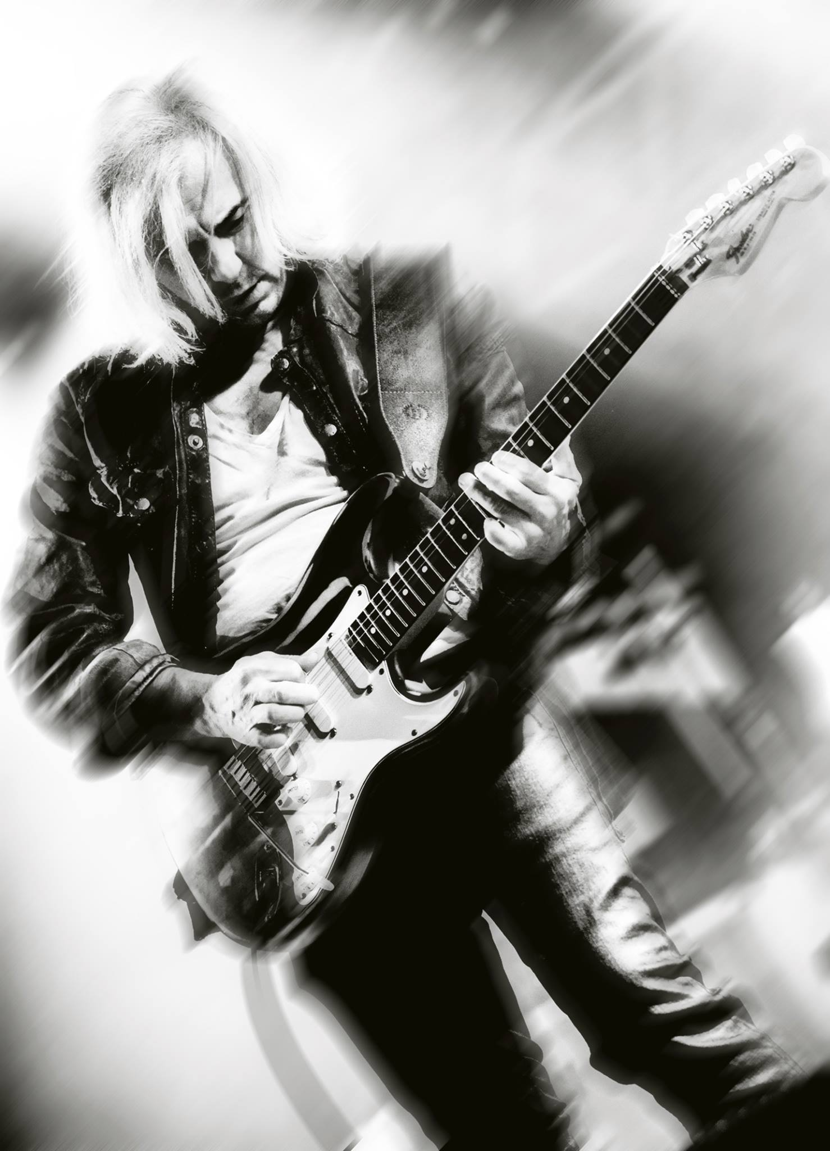

Hermann Skibbe (*1965) graduated from the Munich Guitar Institute in 1989 and has ever since been working as a guitarplayer, singer, composer and producer. His body of work contains many major releases, most of them published via EMI. He wrote scoremusic for some awardwinning movies in Germany (e.g. “Ein Teil von mir” – Max-Ophüls-Award 2009 / “... und wir sind nicht die Einzigen” – Robert-Geissendörfer-Award 2010) and various TV commercials (Ford, McDonald’s, VW). Further studio productions included the title tracks for german TV series “Big Brother” seasons 5 & 6 (in collaboration with drummer Jason Bonham) and recordings with the Prague Philharmonic Orchestra. Since 2013 he’s been working on stage and in studio with some of the best jazz musicians in Europa for the project “Rock the Big Band” (www.rockthebigband.de). The concert film of their show in the Munich Philharmonie was a big sucess when it was broadcasted for 90 minutes this new year’s eve on german television.

Hermann Skibbe released the 4th album of his band in January 2015.

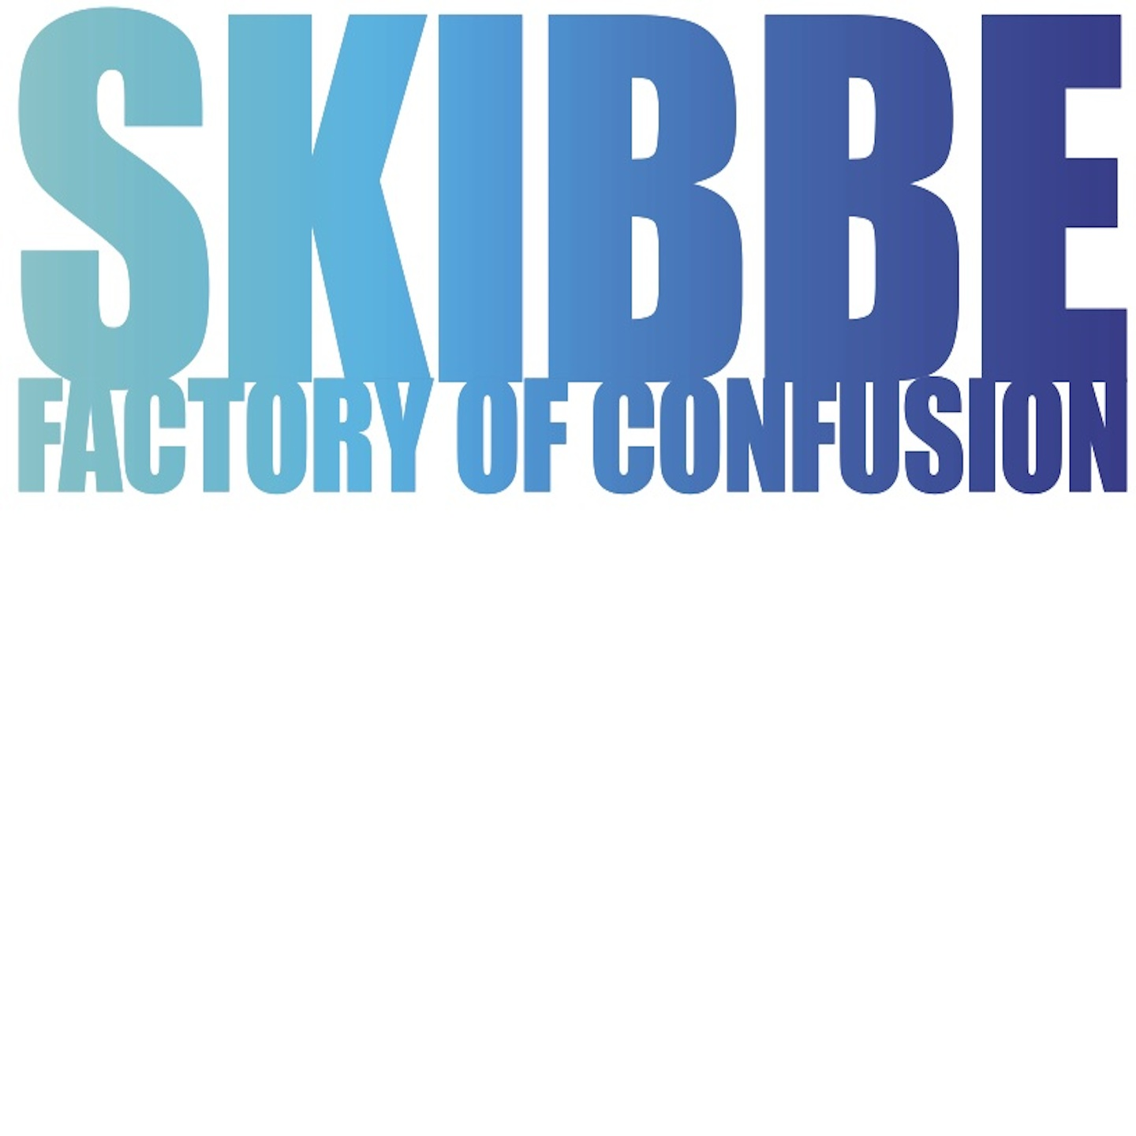

SKIBBE – FACTORY OF CONFUSION

That's how it is entitled - it was written and produced within 6 weeks in the autumn of 2014. He connected the musical themes that popped up in that time period like he usualy does for a movie score.
The melodies and changes appear in many disguises - and so do the lyrical themes.
The main idea was inspired by a nightride on the german Autobahn - hearing the voice from the navigation system saying 'turn left - turn right' maybe one time too much – which on the next day turned out to be the verse of the song 'Factory of Confusion'.
The more confused people are, the easier it is to control them….not only for a navigation system! This could be something like the golden thread for the lyrics of this album.

Hermann himself pretends to be 100% self controlled - which makes him able
to write part 3 and part 2 (in this order) of something intended to be a “Dark Rock Opera”. Part 3 “Master of Confusion” will be more electrical, while Part 2 is supposed be the more acoustical part of this trilogy.

The live performance is supposed to have the digital landscape graphics that can
be seen in some of the videos, the same with the appearances of friend and actor Sky Du Mont who plays the role of the general manager, the CEO of the “FOC”.

Track Listing
- Arrival
- Welcome to the Factory
- Factory of Confusion (Parts I-IV)
- Revolution
- Money
- Hidden*Mystery
- Thing called Blues
- Ill-Usion
- 1200 Friends
- Make your Move
- W.T.O. [Titlesong for the TV series “Diese Kaminskis” on zdf neo]

